From: https://medium.com/@jessesandoval/donald-trumps-vision-for-us-foreign-policy-what-does-america-first-mean-4eeeae24acd
Donald Trump’s Vision for US Foreign Policy: What does ‘America First’ mean?
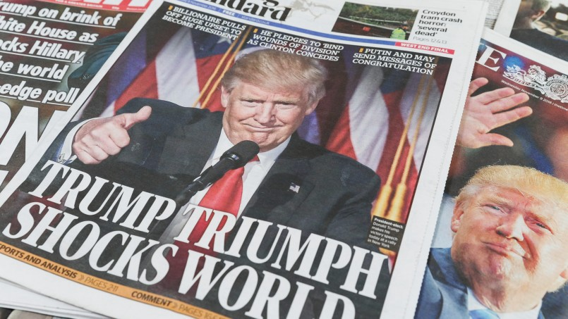
(20220228 Repost from August 15, 2016)
Rather than characterized as a poorly conceived recalibration of American foreign policy bordering on strategic recklessness, Donald J. Trump’s foreign policy statements represent a very consistent and coherent view on America’s interests overseas. Based on the totality of Donald J. Trump’s statements, the vision he presents is one that is indeed a departure from the ideology of liberalism (embracing realism instead), yet strategically sound and ultimately more stable for world affairs.
Donald J. Trump’s basis for American foreign policy mirrors his domestic policy: ‘America first’. This policy emphasizes America’s economic, security and political needs above the needs of friends and enemies. But what exactly does ‘America first’ mean? The following is a summary of America’s core strategic imperative based on Donald J. Trump’s ‘America first’ beliefs:
1. Securing North America;
2. Preventing an outside power from entering the Western Hemisphere;
3. Guaranteeing control of the seas and freedom of navigation;
4. Ensuring no single power controls Eurasia
These fundamental principles serve as the four legs of the ‘American strategic table’. They also fit into Trumps foreign policy paradigm in the following way:
Securing North America: by establishing territorial integrity vis-à-vis Mexico; developing superior terms of trade with our two largest trading partners: Mexico & Canada; ensuring no spill over effects from civil unrest in Mexico or Central America (as was the case during the Mexican Revolution, and most recently due to the drug wars).
Donald J. Trump has consistently delivered a message of American territorial integrity vis-à-vis its neighbors, and economic dominance over their economies by ensuring we maintain more leverage on our neighbors than they do on us (namely through energy, water & food).
Preventing an outside power from entering the Western Hemisphere: actively encouraging the demise of South American governments that are supported by outside powers (namely China, and to a lesser degree Russia & Iran); preventing outside powers from having the military and economic capabilities needed to establish a foothold in the Western Hemisphere.
From the Monroe Doctrine, to the concept of ‘America’s backyard’ a central tenant of American foreign policy has, over the centuries, been to ensure no European or Asian foothold in the Western Hemisphere (think about Imperial Spain in Cuba, the Austro-Hungarian Empire in Mexico, Russia in Alaska, the Soviet Union in Cuba and so on).
While Donald J. Trump has not spoken much about South America, he consistently singled out China as a currency manipulator and trade dumper. By adopting a policy of stricter terms of trade with China, Donald J. Trump is in effect threatening to choke China’s ability to finance economic & political involvement beyond its borders, and therefore reduce the likelihood China would pose a strategic threat to the United States in the Western Hemisphere (much like the Soviet Union did during the Cold War, and Britain, France & Spain did during the 19th century).
Guaranteeing control of the seas and freedom of navigation: ensuring control of the seas by enhancing the world’s preeminent navy; removing threats to freedom of navigation by regional actors, namely
- China in the South China Sea,
- Iran in the Straits of Hormuz and
- Russia in the Baltic and Arctic Seas.
Control of the seas ensures America is not only able to forward deploy force when necessary, but that it can maintain its economic model and export it to its allies by ensuring no disruption to sea lanes and trade routes. Donald J. Trump has consistently argued that America should invest more in its deterrent capabilities (principally our navy), and develop greater leverage against those states that could challenge America’s control of the seas: namely China & Japan.
China has over the past decade undermined regional territorial integrity by challenging the sea borders of nations along the South China Sea (namely Vietnam, The Philippines, Malaysia and Taiwan). The Obama administration has reacted to China’s island building through a combination of surveillance and naval presence. Yet China doesn’t back down. Donald J. Trump’s belief is that we’re not using all the points of leverage at our disposal to achieve the desired outcome. The strongest point of leverage is terms of trade with America. China’s economy depends far more on America than does America on China. By arguing for protectionist trade measures against China, Donald J. Trump is upping the ante; enabling us to threaten China with denial to American market access if it continues to refute the territorial rights of its neighbors.
Lastly, Japan represents a strategic long-term challenge. Our alliance with Japan was a product of the Cold War; we needed to ensure Japan would not threaten America in the Pacific, we needed forward military bases in the Western Pacific, and we wanted a democratic and prosperous Japan as an example of American-sponsored capitalism. Yet with the cold war history, Japan has decided to rely less on the American defense deterrent and instead reinstate offensive military capabilities. In the long run, Japan’s interests in the Western Pacific with [will?] clash with America’s. Donald J. Trump is again using a realist framework by which to view the thawing alliance with Japan; demanding more financial support from the Japanese for the presence of American forces in Okinawa, while simultaneously encouraging Japan to rely on its own deterrent (possibly nuclear) vis-à-vis regional threats from North Korea or China. Indeed, realists like Kenneth Waltz and John Mearsheimer have made similar arguments in the past, that while nuclear proliferation is not desirable, in a local context like the Korean Peninsula, Japanese and South Korean nuclear deterrents would more likely reduce the risk of conflict with North Korea & China as both deterrents would be far more credible than an American promise. No surprise some of our closest allies, Great Britain, Israel and France invested in their own nuclear deterrents so as to not rely on the whims of a White House administration.
Ensuring no single power controls Eurasia: statements against Russian incursions into Ukraine and elsewhere in Eastern Europe; viewing NATO as obsolete and in need of a redesign.
The greatest existential threats to American dominance have historically come from Eurasia; be that the British Empire, Nazi Germany, the Soviet Union, Communist China or any combination thereof. Indeed it is America’s fundamental interest to prevent an amalgamation of Eurasian territories under a single state — hence some of our most fundamental foreign policies: decolonization of European empires, containment of the Soviet Union, a rapprochement with China, and so on. These policies were examples of realism at its best.
Donald J. Trump has similarly advocated realpolitik in his approach to dealing with Russia and Europe. Donald J. Trump agrees that a new policy of containment must be put into effect against Russia, so as to prevent territorial expansion westward (be that Ukraine, the Suwalki Gap or the Baltic States). The best method of checking Russian ambitions is by investing in our deterrent capabilities in Eastern Europe — through ‘trip wire’ defenses like what NATO has recently agreed to provision with the placement of four brigades in the Baltic States and Poland.
Yet Donald J. Trump has also spoken about the obsolete nature of NATO and an unwillingness to support NATO allies that have not contributed the required 2% of GDP to defense spending. Furthermore, Donald J. Trump has welcomed the gradual demise of the European Union by encouraging Brexit. How does this make any sense?
Through a realist framework, these policies are in fact, consistently in America’s long-term interest. NATO occasionally suffers from a misalignment of interests from its members; the Eastern European and Scandinavian members are hawkish against Russia while their Southern and Western counterparts are dovish (hence why Germany free rides on America’s deterrent, whereas frontline states like Greece, Poland and Estonia are the leading defense spenders after America). A revised NATO would better align the interests of Eastern European & Scandinavian members with those of America; namely keeping Russia out and Turkey in check.
Lastly, with regards to the European Union, Donald J. Trump is again correct in encouraging a gradual demise of the political union (not the economic union). A more federalist Europe could, in theory, become less dependent on America and more adversarial to America’s geopolitical interests in Eurasia (think of the proposed European Defense Force). Indeed, an example of this threat is Germany’s cozy relationship with Putin’s Russia; a massive geopolitical risk to the Eastern European states sandwiched in between these powers. So long as Europe fragments back into regional political alliances, America will always be needed to safeguard the interests of local actors as they balance their interests against their stronger neighbors (think of the Visegrad Four against Germany and Russia, or Greece against Turkey). [Hmmm. -FNC]
Concluding Thoughts
Donald J. Trump represents a complete aberration from the liberal order that has been practiced since the end of the Cold War. And this is precisely why his strategic thinking could ensure greater stability for the world. The truth is that American foreign policy teams have over the past twenty-five years done a poor job, and as Stephen M. Walt has noted, that’s a pretty charitable assessment. Aside from a few successes like
- NATO’s expansion eastward and
- Operation Desert Storm [The 1991 Gulf War against Saddam Husein],
the remaining landscape is dotted with failed exercises in nation building (from Afghanistan, to Haiti to Somalia), and wasteful military interventions like Operation Iraqi Freedom. America’s strongest deterrent is its unused military intervention. The more we use force, the higher the likelihood we will fail and suffer blowback. Indeed it's precisely the liberal order, advocating regime change and democratization in societies that have never had functioning democracies, which has lead to a weakening deterrent, regional instability and the election of Islamist parties in the Middle East.
Some of our most coherent foreign policy decisions in the past seventy years were developed while using a realist paradigm; from late-stage involvement in WW2, to containment of the Soviet Union, to the creation of American-led military alliances. Indeed the finest foreign policy moments in the presidencies of FDR, Truman, Eisenhower, Kennedy, Nixon, Reagan, and George H.W. Bush were when a realist approach was utilized to define an America first strategy, and implement it in a cold, calculated and strategic manner. Donald J. Trump will act similarly.
Jesse Sandoval is a graduate of Stanford University in International Relations & Economics. Jesse Sandoval is based in Los Angeles, works in the private equity industry and actively blogs on foreign affairs. He may be contacted at jesse.sandoval@gmail.com and followed @jesssandoval
1

More from Jesse Sandoval

Famously bold authors of The Israel Lobby.

